AI Buddy (Visual Studio) Extension & Hosting DeepSeek LLM Locally

|  |  |
| --- | --- |
| Bert O’Neill | |
| Department: | Software Development |
| Document Title: | Visual Studio AI Prompt Integration |
| Author: | Bert O’Neill |
| Date: | 18-Feb-2025 |
| Version | 1.0 |
| SharePoint |  |
| Document Goals | Provide a user guide, on setting up Ollama, hosting a LLM (locally) and integrating the *AI Buddy* extension within Visual Studio. |

# Revision History

|  |  |  |  |
| --- | --- | --- | --- |
| Date | Version | Description | Author |
| 18/02/2025 | 1.0 | Initial draft | Bert O’Neill |
|  |  |  |  |
|  |  |  |  |
|  |  |  |  |
|  |  |  |  |
|  |  |  |  |

Contents

1. Revision History 1

1. Introduction 3

1.1. Purpose 3

1.2. Scope 3

2. Prerequisites 3

3. LLM Hoster (Ollama) Setup 4

4. Download LLM and Start Hoster 4

5. Install *AI Buddy* Extension (Visual Studio) 4

6. Using AI Buddy 4

7. Miscellaneous 4

# Introduction

This document provides a detailed overview for the design of a BBB application, where instead of using NICE Copy (1 day old) data, use the near live data from the Data Lake.

## Purpose

The Product Architecture Document (PAD) provides a comprehensive architectural overview of the newly proposed features\processes. It presents an architectural view to depict data flow between the various components. It is intended to capture and convey the significant architectural decisions which have been made in designing the system.

## Scope

The scope of this PAD is to convey the architecture involved in upgrading the connections and data retrieved from the Data Lake.

# Prerequisites

* Production database SQL Server hosted on VM *DBSEP5243*
* Testing\Staging SQL Server hosted on VM *APSED4402*
* Development SQL Server hosted on *localhost* (laptop)

# LLM Hoster (Ollama) Setup

# Download LLM and Start Hoster

# Install *AI Buddy* Extension (Visual Studio)

# Using AI Buddy

# Miscellaneous

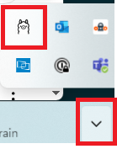

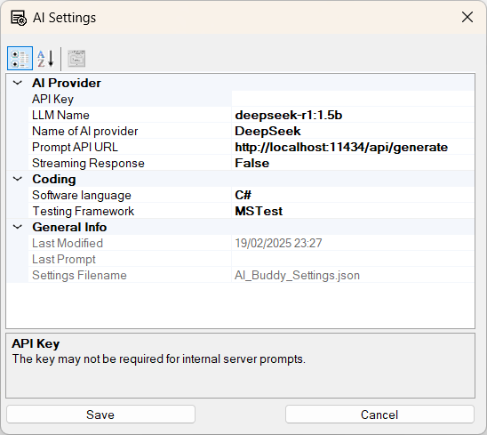

Generate Unit Test For Highlighted Code

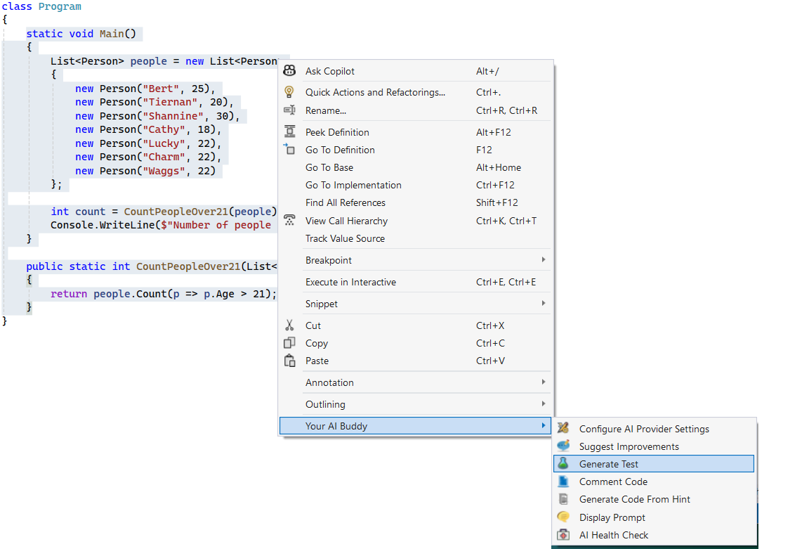

Your selected code will be pasted into a generic prompt for DeepSeek to analysis. An hourglass will appear as DeepSeek is generating a response.

This will then generate several Unit Tests based on your Testing Framework and programming language of choice (which you supplied in the Settings dialog). From here you can copy and paste the code into your test class.

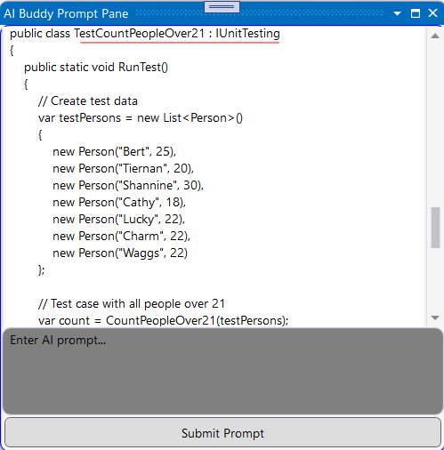

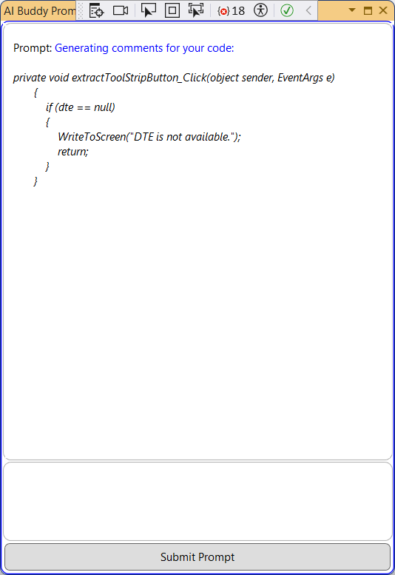

Suggest Coding Improvements

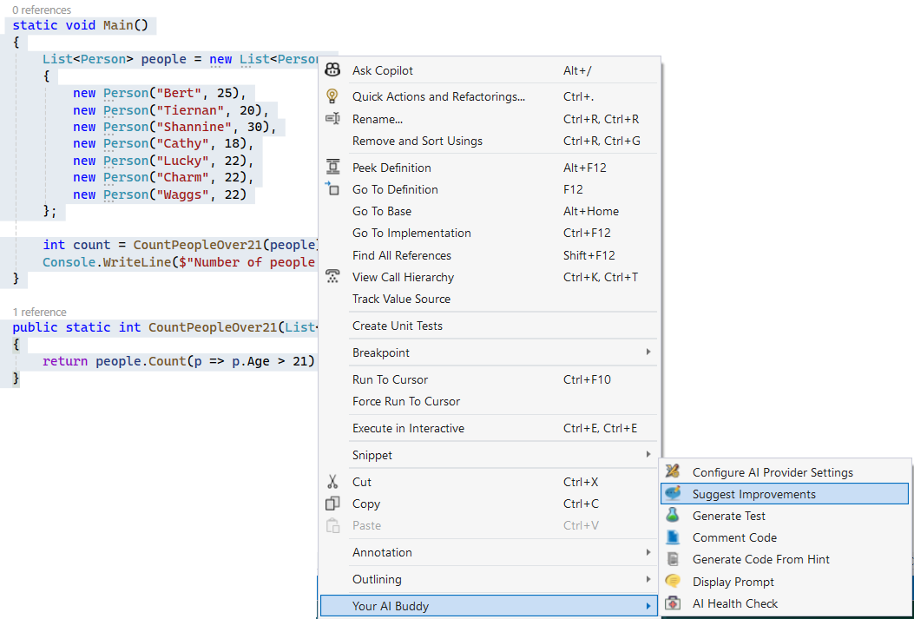

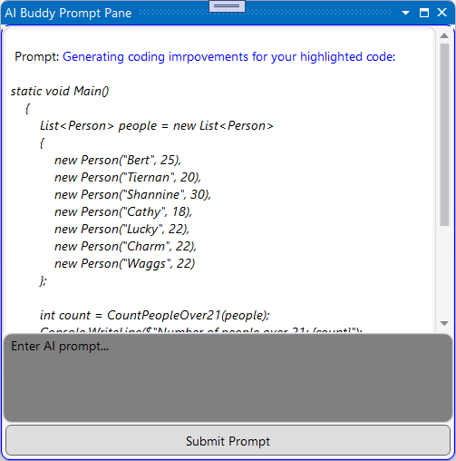

Comment Code

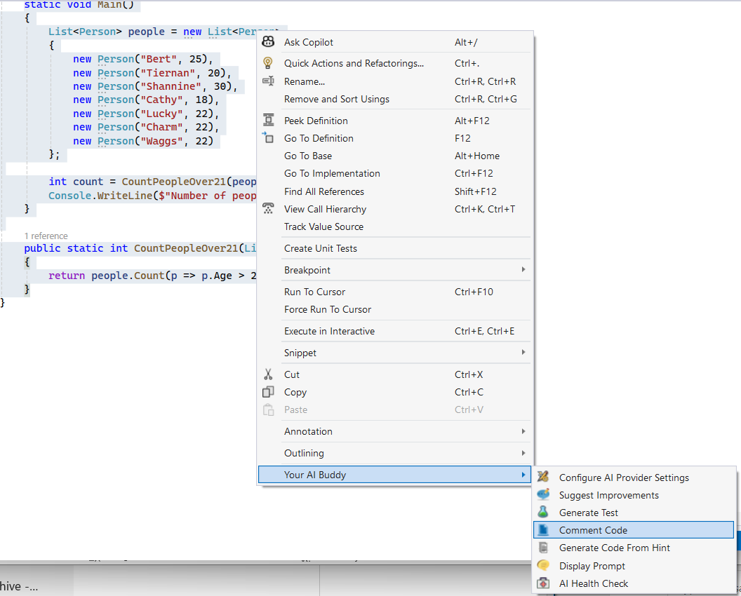

AI Prompt Dialog

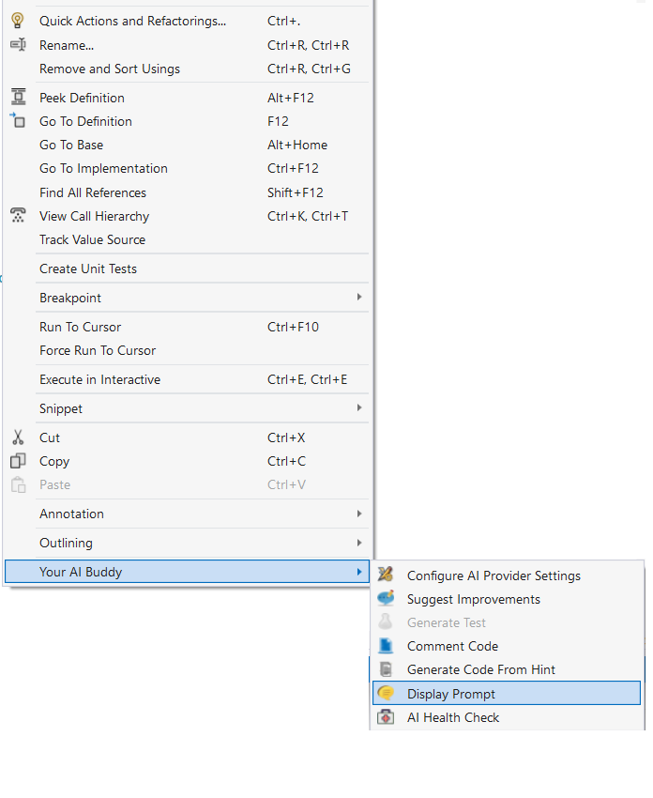

Pasting an image and prompting AI to work with image

Open a Display Prompt as normal, click into the prompt box and paste your image into it (Ctrl V)

